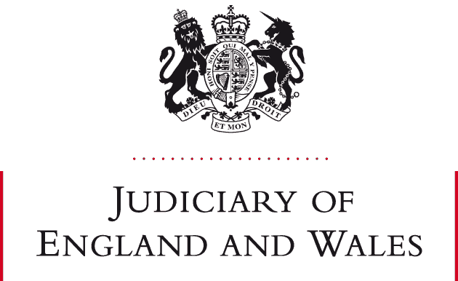
NEWSLETTER UPDATE
10 MAY 2021
Dear all
Family Justice Picnic in the Park: Friday 2 July 2021 from 4.30pm @ Bradgate Park
Now that lockdown measures are gradually being eased and in anticipation of the government’s road map allowing for most restrictions to end by 21 June, we thought it would be nice to have a low key social event to enable everyone to catch up with friends and colleagues. So, whatever your role within Family Justice in Leicestershire, please come along to Bradgate Park from 4.30pm on Friday 2 July 2021. Bring a picnic, something to drink and something to sit on. Bring your family if you would like to. If anyone has any rounders equipment perhaps they will bring it along. Meet near to the Deer Barn Tearoom and Visitor Centre.

Courts will aim to finish by 4pm on this date. If the weather is dreadful and the event has to be postponed, a message will be sent round so keep in touch via the usual channels.
Public Law new forms and orders
Those of you undertaking care cases should be aware of the proposed new forms for use in public law cases that have been published nationally. Word versions of the forms that we intend to start using locally from Tuesday 1 June 2021 are included below. There may be a few changes to these as we continue to discuss them, but any changes are likely to be minor and so I have attached them so you can start to familiarise yourselves with them. Feel free to start using them voluntarily straight away if you wish. The Case Summary document will not apply retrospectively to cases already issued before 1st June but only to those issued from that date. However, the new format is shorter than the current one and so it may be the preference of those drafting them on behalf of the local authority, to use the new template in any event.

I am hoping that it will be possible for these forms to be placed onto the LFJB website for easy access.
Best wishes
HHJ Jane George

